Influencer Inside

Influencer Inside
1.0 Introduction
The "Influencer Inside" is a social media influencer management application used to manage the details of social media influencers and their videos, aiming to track performance, engagement, and content creation. Help them automate the requirements mentioned below by developing a Rest Service using Maven.
1.0 Functional Requirements
You need to implement the Influencer and Video modules of the Influencer Inside application. The client wishes to have restful web services to add a new influencer, modify the details of an influencer, and view the influencer details based on the requirement.
Also, the client wishes to have restful web services for manipulation of video, like adding video, modifying video details, and viewing video details based on the requirement.
2.0 Technical Specifications
The provided InfluencerController and VideoController, which are RestControllers, should be created with the below services:
Services:
InfluencerController
All the below endpoints should return the ResponseEntity
- For success - HttpStatus.OK

Request Method | Request Url | Description
Post | /addInfluencer | This service should add a new Influencer detail by using the addInfluencer method of the InfluencerServiceImpl
Put | /appendFollowersCount/{influencerId}/{incrementCount} | This service should append the followersCount of the influencer with the given influencerId to the given increment by using the appendFollowersCount method of the InfluencerServiceImpl
Get | /viewInfluencerById/{influencerId} | This service should retrieve the existing Influencer details based on influencerId by using the viewInfluencerById method of the InfluencerServiceImpl.
Get | /viewInfluencersByFollowersCount/{lowerLimit}/{higherLimit} | This service should retrieve the list of existing Influencer details based on the provided followers count range by using the viewInfluencersByFollowersCount method of the InfluencerServiceImpl.
Get | /getVideoCountInfluencerwise | This service should retrieve the count of all videos on each influencer by using the getVideoCountInfluencerwise method of the InfluencerServiceImpl  It will return a Map, where the key is the influencerId and the value is the count of all videos for that influencer.

VideoController
All the below endpoints should return the ResponseEntity
- For success - HttpStatus.OK

Request Method | Request Url | Description
Post | /addVideo/{influencerId} | This service takes the Video object and the influencerId as input, and it should add the Video details by using the addVideo method of the VideoServiceImpl.
Put | /updateTitle/{videoId}/{title} | This service should retrieve the existing Video details for the given videoId and update the title by using the updateTitle method of the VideoServiceImpl.
Get | /viewVideosByCategory/{category} | This service should retrieve the existing Video details for the given category by using the viewVideosByCategory method of the VideoServiceImpl.
Get | /viewVideosByInfluencerName/{influencerName} | This service should retrieve the existing Video details for the given influencerName by using the viewVideosByInfluencerName method of the VideoServiceImpl.
Delete | /deleteVideo/{videoId} | This service should delete an existing Video detail by using the deleteVideo method of the VideoServiceImpl.

Service Layer
Refer to the IInfluencerService interface provided as part of the code skeleton. The InfluencerServiceImpl, which is provided as part of the code skeleton, must realize all the methods in the IInfluencerService interface.
Also, an IVideoService interface is provided as part of the code skeleton. The VideoServiceImpl, which is provided as part of the code skeleton, has to realize all the methods in the IVideoService interface.
In the InfluencerServiceImpl and VideoServiceImpl classes, all database-related operations should be implemented using the InfluencerRepository and VideoRepository interfaces, respectively.
Methods in InfluencerServiceImpl
Method in Service | Description | Exception
addInfluencer | This method should add the Influencer details like influencerId, influencerName, platformName, followersCount, expertise, and revenue to the database using InfluencerRepository and return the influencer object.
appendFollowersCount | This method accepts influencerId and incrementCount as parameters. It should check the availability of the Influencer based on the influencerId, and if the Influencer exists, then update the followersCount of that Influencer object with the given incrementCount in the database using InfluencerRepository and return that updated Influencer object. | If no Influencer exists with that influencerId then throw an InvalidInfluencerExecption.
viewInfluencerById | This method accepts influencerId as an argument. It should retrieve the Influencer object from the database whose influencerId was passed as an argument. | If no Influencer exists in that influencerId, then throw an InvalidInfluencerException.
viewInfluencersByFollowersCount | This method accepts two arguments lowerLimit and higherLimit.  It should retrieve the list of Influencer objects that have a followersCount within the given range of lowerLimit and higherLimit, which are passed as parameters (both limits inclusive).
getVideoCountInfluencerwise | This method retrieves the count of all Video posted by each Influencer from the database and returns a Map with a key as the influencerId and a value as the count of all videos posted by that influencer.

Methods in VideoServiceImpl
Method in Service | Description | Exception
addVideo | This method accepts a Video object that holds details like videoId, title, duration, description, and category.  This method should retrieve the Influencer object for the influencerId passed as a parameter.  Next, set that Influencer object to the Video object. Add the Video details to the database using VideoRepository and return the Video object. | If no Influencer exists in that influencer id, then throw an InvalidInfluencerException.
updateTitle | This method accepts videoId and title as parameters. It should check the availability of the Video based on the videoId and update the title of that Video object in the database using VideoRepository, and return that Video object. | If no Video exists in that videoId then throw an InvalidVideoException.
viewVideosByCategory | This method accepts the category as an argument. It should retrieve the list of Video objects in the given category from the database.
viewVideosByInfluencerName | This method accepts the influencerName as an argument. It should retrieve the list of Video objects with the given influencerName from the database.
deleteVideo | This method accepts videoId as an argument. It should delete the Video based on the videoId passed as a parameter and return that Video object. | If no Video exists in that videoId then throw an InvalidVideoException.

Repository Layer
Refer to the InfluencerRepository and VideoRepository interfaces provided as part of the code skeleton. Use appropriate Spring Data JPA for all database-related manipulation.
Also, include the necessary methods to view influencers by followersCount , to get the video count influencer wise in InfluencerRepository, and include the necessary methods to view Video by influencer name and view Video by category in the VideoRepository interface.
Model
Refer to the Model class provided as part of the class diagram/code skeleton and use appropriate annotations for the persistence mapping in the model class.
Model Class - Influencer
Refer to the Influencer and Video class provided as part of the code skeleton, use appropriate annotations to generate getter/setter and an all-argument constructor.
Influencer class
Attribute | Data Type
influencerId | String
influencerName | String
platformName | String
followersCount | int
expertise | String
revenue | double
videoList | List<Video>

Video class
Attribute | Data Type
videoId | String
title | String
duration | double
description | String
category | String
influencerObj | Influencer

Note:
- Use Lombok to generate getters and setters for the attributes
- Also generate all-argument constructor using lombok
- Do not change the datatype or the attribute name provided as part of the code skeleton.

Business Validation
Inbuilt Validation
Rule | Message when validation fails
influencerName should not be empty | Provide value for influencer name
platformName should not be empty | Provide value for platform name
followersCount should be zero or greater | Followers count should be 0 or greater
expertise should not be empty | Provide value for expertise
revenue should be greater than 0 | Revenue should be greater than 0

Rule | Message when validation fails
title should not be empty | Provide value for title
duration should not be within the range 2 to 10 | Duration should be between 2 and 10
description should not be empty | Provide value for description
category should not be empty | Provide value for category

Perform the above Validations using annotations that are available in jakarta.validation.constraints package
Incorporate Exception and validations as ResponseEntity
To incorporate the messages related to Exception and validations (both custom and inbuilt validations) as ResponseEntity, you are provided with the following classes.
- ExceptionResponse class that represents what attributes needs to be there in the customized response error message. Make use of this class to send the customized response error message.
- CustomizedResponseEntityExceptionHandler class to handle all the exceptions that has occurred in the application (both user-defined and pre-defined).
Method Name | Explanation
handleAllExceptions | This method should generally handle all the exceptions.  In ResponseEntity set the HTTPStatus as INTERNAL_SERVER_ERROR.
handleNotFoundException | This method should handle and provide customized error message using Exception Response class for user defined exception InvalidInfluencerException and InvalidVideoException.  In ResponseEntity set the HTTPStatus as NOT_FOUND.
handleMethodArgumentNotValid | This method should handle and provide customized error message using Exception Response class for both pre-defined and user defined validations.  In ResponseEntity set the HTTPStatus as BAD_REQUEST.

3.0 Expected Table Structure
The below table should get created automatically by the application.
- Provide the necessary annotation in the model classes so that the column size for String fields is set to the size mentioned in the below schema diagrams.

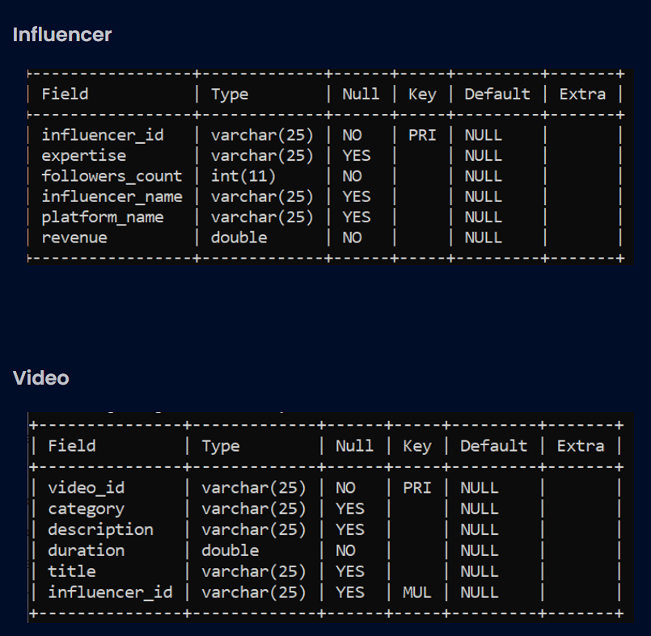
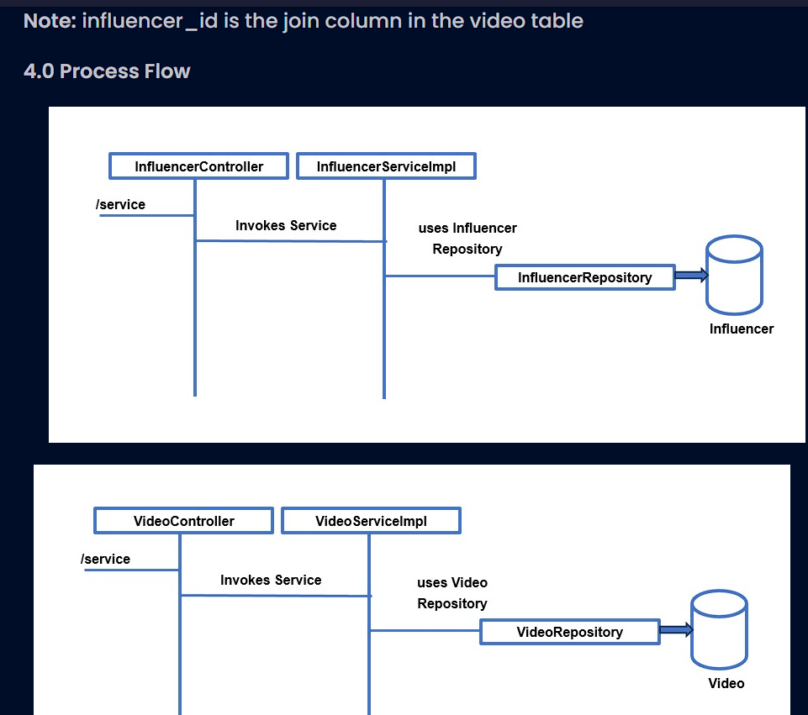

Code here :

InfluencerInside/src/main/resources/application.properties
1
2
3 #Do not change the property name, you can change the value if needed
4 spring.application.name=InflencerInsideApp
5 server.port=7189
6 spring.datasource.driver-class-name=com.mysql.cj.jdbc.Driver
7 spring.jpa.properties.hibernate.dialect= org.hibernate.dialect.MySQL8Dialect
8 spring.datasource.url=jdbc:mysql://localhost:3306/test?createDatabaseIfNotExist=true
9 spring.datasource.username=root
10 spring.datasource.password=
11
12 spring.jpa.generate-ddl=true
13 spring.jpa.hibernate.ddl-auto=none
14
15 # Show or not log for each SQL query
16 spring.jpa.show-sql=true
17
18 # Allows Hibernate to generate SQL optimized for a particular DBMS
19 # spring.jpa.properties.hibernate.dialect=org.hibernate.dialect.MySQL8Dialect
20
InfluencerInside/src/main/java/com/repository/InfluencerRepository.java
1 package com.repository;
2
3 import java.util.List;
4
5 import org.springframework.data.jpa.repository.JpaRepository;
6 import org.springframework.data.jpa.repository.Query;
7 import org.springframework.stereotype.Repository;
8
9 import com.entities.Influencer;
10
11 //Provide necessary annotation
12 @Repository
13 public interface InfluencerRepository extends JpaRepository<Influencer, String>{
14
15 List<Influencer> findByFollowersCountBetween(int lowLimit, int highLimit);
16 //Provide necessary methods to view influencer by followers count and get video count for each influencer
17
18 @Query(value = "SELECT i.influencer_id, COUNT(v.video_id) FROM influencer i LEFT JOIN video v ON i.influencer_id = v.influencer_id GROUP BY i.influencer_id", nativeQuery = true)
19 public List<Object[]> getVideoCountInfluencerwise();
20
21 }
22
InfluencerInside/src/main/java/com/repository/VideoRepository.java
1 package com.repository;
2
3 import java.util.List;
4
5 import org.springframework.data.jpa.repository.JpaRepository;
6 import org.springframework.stereotype.Repository;
7
8 import com.entities.Video;
9
10 //Provide necessary annotation
11 @Repository
12 public interface VideoRepository extends JpaRepository<Video, String>{
13
14 List<Video> findByCategoryIgnoreCase(String category);
15 // Provide necessary methods to view videos by category and influencer name
16
17 List<Video> findByInfluencerObjInfluencerNameIgnoreCase(String influencerName);
18
19
20 }
21

InfluencerInside/src/main/java/com/service/IVideoService.java
1 package com.service;
2
3 import java.util.List;
4 import com.entities.Video;
5 import com.exception.InvalidInfluencerException;
6 import com.exception.InvalidVideoException;
7
8 public interface IVideoService {
9
10 public Video addVideo( Video video, String influencerId) throws InvalidInfluencerException;
11 public Video updateTitle( String videoId, String title) throws InvalidVideoException;
12 public List<Video> viewVideosByCategory ( String category);
13 public List<Video> viewVideosByInfluencerName (String influencerName );
14 public Video deleteVideo(String videoId);
15 }
16
InfluencerInside/src/main/java/com/controller/InfluencerController.java
1 package com.controller;
2
3 import java.util.List;
4 import java.util.Map;
5
6 import org.springframework.beans.factory.annotation.Autowired;
7 import org.springframework.http.HttpStatus;
8 import org.springframework.http.ResponseEntity;
9 import org.springframework.stereotype.Controller;
10 import org.springframework.validation.annotation.Validated;
11 import org.springframework.web.bind.annotation.GetMapping;
12 import org.springframework.web.bind.annotation.PathVariable;
13 import org.springframework.web.bind.annotation.PostMapping;
14 import org.springframework.web.bind.annotation.PutMapping;
15 import org.springframework.web.bind.annotation.RequestBody;
16
17 import com.entities.Influencer;
18 import com.exception.InvalidInfluencerException;
19 import com.service.IInfluencerService;
20
21 //Provide necessary Annotation
22 @Controller
23 public class InfluencerController {
24
25 // Provide necessary Annotation
26 @Autowired
27 private IInfluencerService influencerService;
28
29 // Provide necessary Annotation for the below methods and fill the code
30 @PostMapping("/addInfluencer")
31 public ResponseEntity<Influencer> addInfluencer(@RequestBody @Validated Influencer influencer) {
32 return new ResponseEntity<>(influencerService.addInfluencer(influencer), HttpStatus.OK);
33 }
34 @PutMapping("/appendFollowersCount/{influencerId}/{incrementCount}")
35 public ResponseEntity<Influencer> appendFollowersCount(@PathVariable String influencerId,@PathVariable int incrementCount)throws InvalidInfluencerException {
36 return new ResponseEntity<>(influencerService.appendFollowersCount(influencerId,incrementCount), HttpStatus.OK);
37 }
38 @GetMapping("/viewInfluencerById/{influencerId}")
39 public ResponseEntity<Influencer> viewInfluencerById(@PathVariable String influencerId) throws InvalidInfluencerException {
40 return new ResponseEntity<>(influencerService.viewInfluencerById(influencerId), HttpStatus.OK);
41 }
42 @GetMapping("/viewInfluencersByFollowersCount/{lowerLimit}/{higherLimit}")
43 public ResponseEntity<List<Influencer>> viewInfluencersByFollowersCount(@PathVariable int lowerLimit,@PathVariable int higherLimit) {
44 return new ResponseEntity<>(influencerService.viewInfluencersByFollowersCount(lowerLimit,higherLimit), HttpStatus.OK);
45 }
46 @GetMapping("/getVideoCountInfluencerwise")
47 public ResponseEntity<Map<String, Integer>> getVideoCountInfluencerwise() {
48 return new ResponseEntity<>(influencerService.getVideoCountInfluencerwise(), HttpStatus.OK);
49 }
50 }
51
InfluencerInside/src/main/java/com/service/InfluencerServiceImpl.java
1 package com.service;
2
3 import java.util.List;
4 import java.util.Map;
5 import java.util.Optional;
6 import java.util.stream.Collectors;
7
8 import org.springframework.beans.factory.annotation.Autowired;
9 import org.springframework.stereotype.Service;
10
11 import com.entities.Influencer;
12 import com.repository.InfluencerRepository;
13 import com.repository.VideoRepository;
14 import com.exception.InvalidInfluencerException;
15
16 //Provide necessary annotation
17 @Service
18 public class InfluencerServiceImpl implements IInfluencerService {
19
20 // Provide necessary annotation
21 @Autowired
22 private InfluencerRepository influencerRepository;
23
24 // Provide necessary Annotation
25 @Autowired
26 private VideoRepository videoRepository;
27
28 public Influencer addInfluencer(Influencer influencer) {
29 // fill code
30
31 return influencerRepository.save(influencer);
32 }
33
34 public Influencer appendFollowersCount(String influencerId, int incrementCount) throws InvalidInfluencerException {
35 // fill code
36 Optional<Influencer> opt = influencerRepository.findById(influencerId);
37 if (!opt.isPresent()) {
38 throw new InvalidInfluencerException();
39 }
40
41 Influencer influencer = opt.get();
42 influencer.setFollowersCount(influencer.getFollowersCount() + incrementCount);
43 return influencerRepository.save(influencer);
44
45 }
46
47 public Influencer viewInfluencerById(String influencerId) throws InvalidInfluencerException {
48 // fill code
49 return influencerRepository.findById(influencerId).orElseThrow(() -> new InvalidInfluencerException());
50
51 }
52
53 public List<Influencer> viewInfluencersByFollowersCount(int lowLimit, int highLimit) {
54 // fill code
55
56 return influencerRepository.findByFollowersCountBetween(lowLimit, highLimit);
57 }
58
59 public Map<String, Integer> getVideoCountInfluencerwise() {
60 // fill code
61 List<Object[]> results = influencerRepository.getVideoCountInfluencerwise();
62 return results.stream()
63 .collect(Collectors.toMap(
64 result -> (String) result[0],
65 result -> ((Number) result[1]).intValue()
66 ));
67 }
68 }
69
InfluencerInside/src/main/java/com/service/VideoServiceImpl.java
1 package com.service;
2
3 import java.util.List;
4 import java.util.Optional;
5
6 import org.springframework.beans.factory.annotation.Autowired;
7 import org.springframework.stereotype.Service;
8
9 import com.entities.Influencer;
10 import com.entities.Video;
11 import com.exception.InvalidInfluencerException;
12 import com.exception.InvalidVideoException;
13 import com.repository.InfluencerRepository;
14 import com.repository.VideoRepository;
15
16 //Provide necessary annotation
17 @Service
18 public class VideoServiceImpl implements IVideoService {
19
20 // Provide necessary annotation
21 @Autowired
22 private VideoRepository videoRepository;
23
24 // Provide necessary Annotation
25 @Autowired
26 private InfluencerRepository influencerRepository;
27
28 public Video addVideo(Video video, String influencerId) throws InvalidInfluencerException {
29 // fill code
30 Optional<Influencer> opt = influencerRepository.findById(influencerId);
31 if (!opt.isPresent()) {
32 throw new InvalidInfluencerException();
33 }
34
35 video.setInfluencerObj(opt.get());
36 return videoRepository.save(video);
37
38 }
39
40 public Video updateTitle(String videoId, String title) throws InvalidVideoException {
41 // fill code
42 Optional<Video> opt = videoRepository.findById(videoId);
43 if (!opt.isPresent()) {
44 throw new InvalidVideoException();
45 }
46
47 Video video = opt.get();
48 video.setTitle(title);
49 return videoRepository.save(video);
50
51 }
52
53 public List<Video> viewVideosByCategory(String category) {
54 // fill code
55
56 return videoRepository.findByCategoryIgnoreCase(category);
57 }
58
59 public List<Video> viewVideosByInfluencerName(String influencerName) {
60 // fill code
61
62 return videoRepository.findByInfluencerObjInfluencerNameIgnoreCase(influencerName);
63 }
64
65 public Video deleteVideo(String videoId) {
66 // fill code
67
68 Optional<Video> opt = videoRepository.findById(videoId);
69 if (opt.isPresent()) {
70 videoRepository.deleteById(videoId);
71 return opt.get();
72 }
73 return null;
74
75 }
76
77 }
78
InfluencerInside/src/main/java/com/controller/VideoController.java
1 package com.controller;
2
3 import java.util.List;
4
5 import org.springframework.beans.factory.annotation.Autowired;
6 import org.springframework.http.HttpStatus;
7 import org.springframework.http.ResponseEntity;
8 import org.springframework.stereotype.Controller;
9 import org.springframework.validation.annotation.Validated;
10 import org.springframework.web.bind.annotation.DeleteMapping;
11 import org.springframework.web.bind.annotation.GetMapping;
12 import org.springframework.web.bind.annotation.PathVariable;
13 import org.springframework.web.bind.annotation.PostMapping;
14 import org.springframework.web.bind.annotation.PutMapping;
15 import org.springframework.web.bind.annotation.RequestBody;
16
17 import com.entities.Video;
18 import com.exception.InvalidInfluencerException;
19 import com.exception.InvalidVideoException;
20 import com.service.IVideoService;
21
22 //Provide necessary Annotation
23 @Controller
24 public class VideoController {
25
26 // Provide necessary Annotation
27 @Autowired
28 private IVideoService videoService;
29
30 // Provide necessary Annotation for the below methods and fill the code
31 @PostMapping("/addVideo/{influencerId}")
32 public ResponseEntity<Video> addVideo(@RequestBody @Validated Video video, @PathVariable String influencerId) throws InvalidInfluencerException {
33 return new ResponseEntity<>(videoService.addVideo(video,influencerId), HttpStatus.OK);
34 }
35 @PutMapping("/updateTitle/{videoId}/{title}")
36 public ResponseEntity<Video> updateTitle(@PathVariable String videoId,@PathVariable String title) throws InvalidVideoException {
37 return new ResponseEntity<>(videoService.updateTitle(videoId,title), HttpStatus.OK);
38 }
39 @GetMapping("/viewVideosByCategory/{category}")
40 public ResponseEntity<List<Video>> viewVideosByCategory(@PathVariable String category) {
41 return new ResponseEntity<>(videoService.viewVideosByCategory(category), HttpStatus.OK);
42 }
43 @GetMapping("/viewVideosByInfluencerName/{influencerName}")
44 public ResponseEntity<List<Video>> viewVideosByInfluencerName(@PathVariable String influencerName) {
45 return new ResponseEntity<>(videoService.viewVideosByInfluencerName(influencerName), HttpStatus.OK);
46 }
47 @DeleteMapping("/deleteVideo/{videoId}")
48 public ResponseEntity<Video> deleteVideo(@PathVariable String videoId) {
49 return new ResponseEntity<>(videoService.deleteVideo(videoId), HttpStatus.OK);
50 }
51
52 }
53
InfluencerInside/src/main/java/com/entities/Influencer.java
1 package com.entities;
2
3 import java.util.List;
4
5 import com.fasterxml.jackson.annotation.JsonIgnoreProperties;
6
7 import jakarta.persistence.CascadeType;
8 import jakarta.persistence.Column;
9 import jakarta.persistence.Entity;
10 import jakarta.persistence.Id;
11 import jakarta.persistence.OneToMany;
12 import jakarta.validation.constraints.NotEmpty;
13 import jakarta.validation.constraints.Positive;
14 import jakarta.validation.constraints.PositiveOrZero;
15 import lombok.AllArgsConstructor;
16 import lombok.Data;
17
18 //Provide necessary Annotation
19 @Data
20 @Entity
21 @AllArgsConstructor
22 public class Influencer {
23
24 // Provide necessary Annotation
25 @Id
26 @Column(length = 25)
27 private String influencerId;
28 @Column(length = 25)
29 @NotEmpty(message = "Provide value for influencer name")
30 private String influencerName;
31 @Column(length = 25)
32 @NotEmpty(message = "Provide value for platform name")
33 private String platformName;
34 @PositiveOrZero(message = "Followers count should be 0 or greater")
35 private int followersCount;
36 @Column(length = 25)
37 @NotEmpty(message = "Provide value for expertise")
38 private String expertise;
39 @Positive(message = "Revenue should be greater than 0")
40 private double revenue;
41
42 // Provide necessary Annotations
43
44 @OneToMany(cascade = CascadeType.ALL, mappedBy = "influencerObj")
45 @JsonIgnoreProperties
46 private List<Video> videoList;
47
48 public Influencer() {
49 super();
50 }
51
52 }
53
InfluencerInside/src/main/java/com/entities/Video.java
1 package com.entities;
2
3 import com.fasterxml.jackson.annotation.JsonIgnoreProperties;
4
5 import jakarta.persistence.Column;
6 import jakarta.persistence.Entity;
7 import jakarta.persistence.Id;
8 import jakarta.persistence.JoinColumn;
9 import jakarta.persistence.ManyToOne;
10 import jakarta.validation.constraints.Max;
11 import jakarta.validation.constraints.Min;
12 import jakarta.validation.constraints.NotEmpty;
13 import lombok.AllArgsConstructor;
14 import lombok.Data;
15
16 //Provide necessary Annotation
17 @Data
18 @Entity
19 @AllArgsConstructor
20 public class Video {
21
22 // Provide necessary Annotation
23 @Id
24 @Column(length = 25)
25 private String videoId;
26 @Column(length = 25)
27 @NotEmpty(message = "Provide value for title")
28 private String title;
29 @Min(value = 2, message = "Duration should be between 2 and 10")
30 @Max(value = 10, message = "Duration should be between 2 and 10")
31 private double duration;
32 @Column(length = 25)
33 @NotEmpty(message = "Provide value for description")
34 private String description;
35 @Column(length = 25)
36 @NotEmpty(message = "Provide value for category")
37 private String category;
38
39 // Provide necessary Annotations
40 @ManyToOne
41 @JoinColumn(name = "influencer_id")
42 @JsonIgnoreProperties
43 private Influencer influencerObj;
44
45 public Video() {
46 super();
47 }
48
49 }
50
InfluencerInside/src/main/java/com/example/demo/InfluencerInsideApplication.java
1 package com.example.demo;
2
3 import org.springframework.boot.SpringApplication;
4 import org.springframework.boot.autoconfigure.SpringBootApplication;
5 import org.springframework.boot.autoconfigure.domain.EntityScan;
6 import org.springframework.context.annotation.ComponentScan;
7 import org.springframework.data.jpa.repository.config.EnableJpaRepositories;
8
9 @EntityScan("com.entities")
10 @ComponentScan(basePackages={"com.repository","com.controller","com.entities","com.service","com.exception"})
11 @EnableJpaRepositories("com.repository")
12 @SpringBootApplication
13 public class InfluencerInsideApplication {
14
15 public static void main(String[] args) {
16 SpringApplication.run(InfluencerInsideApplication.class, args);
17
18 }
19
20 }
21
InfluencerInside/src/main/java/com/exception/CustomizedResponseEntityExceptionHandler.java
1 package com.exception;
2
3 import org.springframework.http.HttpHeaders;
4 import org.springframework.http.HttpStatus;
5 import org.springframework.http.HttpStatusCode;
6 import org.springframework.http.ResponseEntity;
7 import org.springframework.web.bind.MethodArgumentNotValidException;
8 import org.springframework.web.bind.annotation.ExceptionHandler;
9 import org.springframework.web.bind.annotation.RestControllerAdvice;
10 import org.springframework.web.context.request.WebRequest;
11 import org.springframework.web.servlet.mvc.method.annotation.ResponseEntityExceptionHandler;
12
13 import java.time.LocalDate;
14 import java.util.stream.Collectors;
15
16 import com.exception.*;
17
18 @RestControllerAdvice
19 public class CustomizedResponseEntityExceptionHandler extends ResponseEntityExceptionHandler {
20
21 @ExceptionHandler(Exception.class)
22 public final ResponseEntity<Object> handleAllExceptions(Exception ex, WebRequest request) {
23 ExceptionResponse exceptionResponse = new ExceptionResponse(LocalDate.now(), ex.getMessage(),
24 request.getDescription(false), HttpStatus.INTERNAL_SERVER_ERROR.getReasonPhrase());
25 return new ResponseEntity<>(exceptionResponse, HttpStatus.INTERNAL_SERVER_ERROR);
26 }
27
28 @ExceptionHandler({ InvalidInfluencerException.class, InvalidVideoException.class })
29 public final ResponseEntity<ExceptionResponse> handleNotFoundException(RuntimeException ex, WebRequest request) {
30 ExceptionResponse exceptionResponse = new ExceptionResponse(LocalDate.now(), ex.getMessage(),
31 request.getDescription(false), HttpStatus.NOT_FOUND.getReasonPhrase());
32 return new ResponseEntity<>(exceptionResponse, HttpStatus.NOT_FOUND);
33 }
34
35 @Override
36 protected ResponseEntity<Object> handleMethodArgumentNotValid(MethodArgumentNotValidException ex,
37 HttpHeaders headers, HttpStatusCode status, WebRequest request) {
38 String details = ex.getBindingResult().getFieldErrors().stream()
39 .map(e -> e.getField() + ": " + e.getDefaultMessage()).collect(Collectors.joining(", "));
40 ExceptionResponse exceptionResponse = new ExceptionResponse(LocalDate.now(), "Validation Failed", details,
41 HttpStatus.BAD_REQUEST.getReasonPhrase());
42 return new ResponseEntity<>(exceptionResponse, HttpStatus.BAD_REQUEST);
43 }
44 }
InfluencerInside/src/main/java/com/exception/ExceptionResponse.java
1 package com.exception;
2
3 import java.time.LocalDate;
4 import lombok.AllArgsConstructor;
5 import lombok.Data;
6 import lombok.Getter;
7 import lombok.Setter;
8 @Data
9 @Getter
10 @Setter
11 @AllArgsConstructor
12 public class ExceptionResponse {
13 private LocalDate timestamp;
14 private String message;
15 private String details;
16 private String httpCodeMessage;
17 }
18
InfluencerInside/src/main/java/com/exception/InvalidInfluencerException.java
1 package com.exception;
2
3 public class InvalidInfluencerException extends Exception {
4
5 }
6
InfluencerInside/src/main/java/com/exception/InvalidVideoException.java
1 package com.exception;
2
3 public class InvalidVideoException extends Exception {
4
5 }
6
InfluencerInside/src/main/java/com/service/IInfluencerService.java
1 package com.service;
2
3 import java.util.List;
4 import java.util.Map;
5 import com.entities.Influencer;
6 import com.exception.InvalidInfluencerException;
7
8 public interface IInfluencerService {
9
10 public Influencer addInfluencer(Influencer influencer);
11 public Influencer appendFollowersCount(String influencerId, int incrementCount) throws InvalidInfluencerException;
12 public Influencer viewInfluencerById (String influencerId ) throws InvalidInfluencerException;
13 public List<Influencer> viewInfluencersByFollowersCount (int lowLimit, int highLimit);
14 public Map<String,Integer> getVideoCountInfluencerwise();
15
}

2nd Question :

Bite Blitz
BiteBlitz
1.0 Introduction
The BiteBlitz is an online food ordering platform that makes delivery from any restaurant to anywhere in this city. They approach you to create an application to manage the restaurant and its order details from various users on an online food ordering platform. Help them automate the below-mentioned requirements by developing a Rest Service using Maven.
1.1 Functional Requirements
You need to implement the Restaurant and Order module of the online learning application. The client wishes to have restful web services to add a new Restaurant, modify the details of a Restaurant, and view the Restaurant details based on the requirement.
Also, the client wishes to have restful web services for manipulation of orders, like adding orders, modifying order details, and viewing order details based on the requirement.
2.0 Technical Specifications
The provided RestaurantController and OrderController, which are RestControllers, should be created with the below services:
Services:
RestaurantController
All the below endpoints should return the ResponseEntity
- For success - HttpStatus.OK

Request Method | Request Url | Description
Post | /addRestaurant | This service should add Restaurant details by using the addRestaurant method of the RestaurantServiceImpl.
Get | /viewRestaurantById/{restaurantId} | This service should retrieve the existing Restaurant details based on restaurantId by using the viewRestaurantById method of the RestaurantServiceImpl.
Get | /viewRestaurantsByRatingAndLocation/{rating}/{location} | This service should retrieve the existing Restaurant details based on the rating greater than or equal to the given rating and the location matching the given location by using the viewRestaurantsByRatingAndLocation method of the RestaurantServiceImpl.
Put | /updateRestaurantRating/{restaurantId}/{rating} | This service should update the rating of the Restaurant with the given restaurantId to the given rating by using the updateRestaurantRating method of the RestaurantServiceImpl.
Get | /getOrderCountRestaurantWise | This service should retrieve the count of Orders for each Restaurant by using the getOrderCountRestaurantWise method of the RestaurantServiceImpl.

OrderController
All the below endpoints should return the ResponseEntity
- For success - HttpStatus.OK

Request Method | Request Url | Description
Post | /addOrder/{restaurantId} | This service takes the Order object and the restaurantId as input, and it should add the Order details by using the addOrder method of the OrderServiceImpl
Put | /updatePaymentMethod/{orderId}/{paymentMethod} | This service should retrieve the existing Order details for the given orderId and update the paymentMethod by using the updatePaymentMethod method of the OrderServiceImpl
Get | /viewOrdersByStatus/{status} | This service should retrieve the existing Order details for the given status by using the viewOrdersByStatus method of the OrderServiceImpl
Get | /viewOrdersByRestaurantName/{restaurantName} | This service should retrieve the existing Order details for the given restaurantName by using the viewOrdersByRestaurantName method of the OrderServiceImpl
Delete | /cancelOrder/{orderId} | This service should delete an existing Order detail by using the cancelOrder method of the OrderServiceImpl.

Service Layer
Refer to the IRestaurantService interface provided as part of the code skeleton. The RestaurantServiceImpl, which is provided as part of the code skeleton, has to realize all the methods in the IRestaurantService interface.
Also, the IOrderService interface is provided as part of the code skeleton. The OrderServiceImpl, which is provided as part of the code skeleton, has to realize all the methods in the IOrderService interface.
In the RestaurantServiceImpl and OrderServiceImpl classes, all database-related operations should be implemented using the RestaurantRepository and OrderRepository interfaces, respectively.
Methods in RestaurantServiceImpl
Method in Service | Description | Exception
addRestaurant | This method should add Restaurant details like restaurantId, restaurantName, cuisine, rating, and location to the database using RestaurantRepository and return the restaurant object.
viewRestaurantById | This method accepts restaurantId as an argument. It should retrieve the Restaurant object from the database whose restaurantId was passed as an argument. | If no Restaurant exists with that restaurantId, then throw an InvalidRestaurantException.
viewRestaurantsByRatingAndLocation | This method accepts a rating and a location as arguments. It retrieves a list of Restaurant objects from the database where the rating is greater than or equal to the given rating and the location matches the given location.
updateRestaurantRating | This method accepts restaurantId and rating as parameters. It should check the availability of the Restaurant based on the restaurantId and if the restaurant exists, then update the rating of that Restaurant object with the given rating in the database using RestaurantRepository and return that updated Restaurant object. | If no Restaurant exists with that restaurantId, then throw an InvalidRestaurantException.
getOrderCountRestaurantWise | This method retrieves the count of orders in each Restaurant from the database and returns a Map with a key as restaurantId and a value as the count of orders in that restaurant.

Methods in OrderServiceImpl
Method in Service | Description | Exception
addOrder | This method accepts an Order object that holds details like orderId, status, deliveryAddress, paymentMethod, and totalAmount. This method should retrieve the Restaurant object for the restaurantId passed as a parameter.  Next, set that Restaurant object to the Order object. Add the Order details to the database using OrderRepository and return the Order object. | If no Restaurant exists with that restaurantId, then throw an InvalidRestaurantException.
updatePaymentMethod | This method accepts orderId and paymentMethod as parameters. It should check the availability of the Order based on the orderId and update the paymentMethod of that Order object in the database using OrderRepository, and return that Order object. | If no Order exists in that orderId, then throw an InvalidOrderException.
viewOrdersByStatus | This method accepts the status as an argument. It should retrieve the list of Order objects with the given status from the database.
viewOrdersByRestaurantName | This method accepts the restaurantName as an argument. It should retrieve the list of Order objects with the given restaurantName from the database.
cancelOrder | This method accepts orderId as an argument. It should delete the Order based on the orderId passed as a parameter and return that Order object. | If no order exists with that orderId, then throw an InvalidOrderException.

Repository Layer
Refer to the RestaurantRepository and OrderRepository interfaces provided as part of the code skeleton. Use appropriate Spring Data JPA for all database-related manipulation.
Also include the necessary methods to view Restaurant by rating and location, to get the order count restaurant-wise in RestaurantRepository, and to view Order by restaurant name and view Order by status in the OrderRepository interface.
Model
Refer to the Model class provided as part of the class diagram/code skeleton, and use appropriate annotations for the persistence mapping in the model class.
Note that one Order object is related to one Restaurant object and one Restaurant object can be related to multiple Order objects.

Model Class
Refer to the Restaurant and Orders class provided as part of the code skeleton, use appropriate annotations to generate a getter/setter, and use an all-argument constructor.
Restaurant class
Attribute | Data Type
restaurantId | int
restaurantName | String
cuisine | String
rating | double
location | String
ordersList | List<Orders>

Orders class
Attribute | Data Type
orderId | int
deliveryAddress | String
paymentMethod | String
status | String
totalAmount | double
restaurantObj | Restaurant

Note:
- Use Lombok to generate getters and setters for the attributes
- Also generate all-argument constructor using lombok
- Do not change the datatype or the attribute name provided as part of the code skeleton
Business Validation
Inbuilt Validation
Rule | Message when validation fails
restaurantId should be greater than zero | Restaurant id should be greater than 0
restaurantName should not be empty | Provide value for restaurant name
cuisine should not be empty | Provide value for cuisine
rating should between 1 and 10 | Rating should be between 1 and 10
Location should not be empty | Provide value for location

Rule | Message when validation fails
orderId should be greater than zero | Order id should be greater than 0
deliveryAddress should not be empty | Provide value for delivery address
paymentMethod should not be empty | Provide value for payment method
Status should not be empty | Provide value for status
totalAmount should be greater than zero | Total amount should be greater than 0
Perform the above validations using annotations that are available in jakarta.validation.constraints package.
Incorporate Exception and validations as ResponseEntity
To incorporate the messages related to Exception and validations (both custom and inbuilt validations) as ResponseEntity, you are provided with the following classes.
- ExceptionResponse class that represents what attributes needs to be there in the customized response error message. Make use of this class to send the customized response error message.
- CustomizedResponseEntityExceptionHandler class to handle all the exceptions that has occurred in the application (both user-defined and pre-defined).
Method Name | Explanation
handleAllExceptions | This method should generally handle all the exceptions.  In ResponseEntity set the HTTPStatus as INTERNAL_SERVER_ERROR.
handleNotFoundException | This method should handle and provide customized error message using Exception Response class for user defined exception InvalidRestaurantException and InvalidOrderException  In ResponseEntity set the HTTPStatus as NOT_FOUND.
handleMethodArgumentNotValid | This method should handle and provide customized error message using Exception Response class for both pre-defined and user defined validations.  In ResponseEntity set the HTTPStatus as BAD_REQUEST.

3.0 Expected Table Structure
The below table should get created automatically by the application.
Note
- Provide the necessary annotation in the model classes so that the column size for String fields is set to the size mentioned in the below schema diagrams.

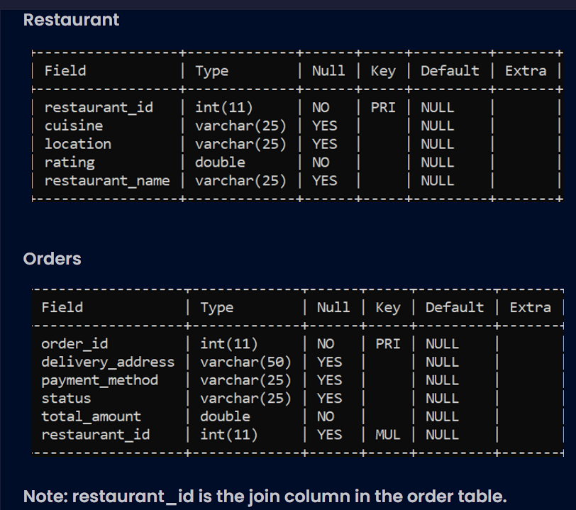
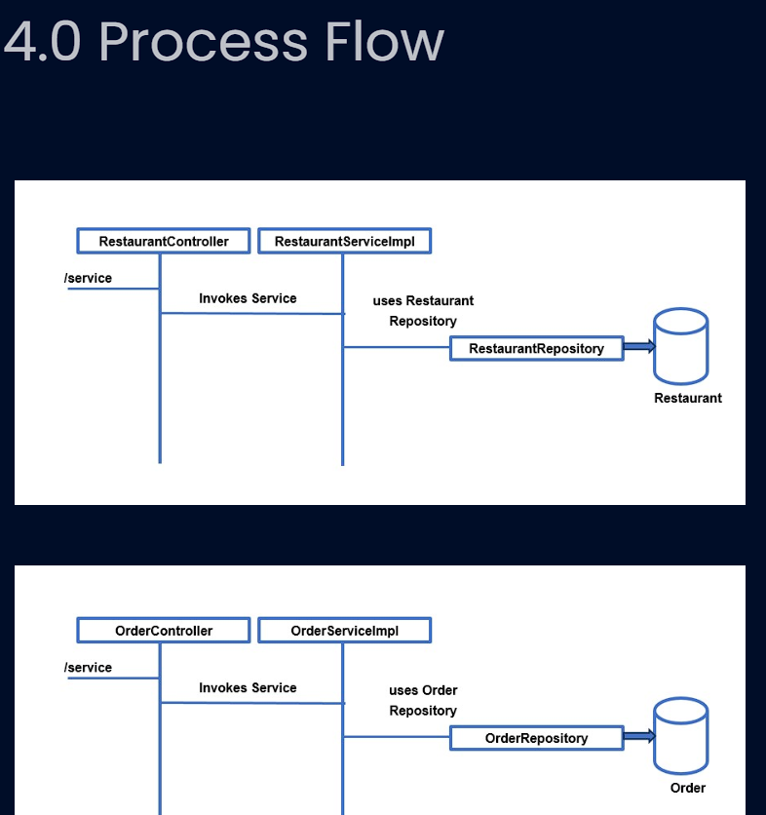

Automatic evaluation[+]
BiteBlitz/src/main/java/com/exception/CustomizedResponseEntityExceptionHandler.java
1 package com.exception;
2
3 import org.springframework.http.HttpHeaders;
4 import org.springframework.http.HttpStatus;
5 import org.springframework.http.HttpStatusCode;
6 import org.springframework.http.ResponseEntity;
7 import org.springframework.web.bind.MethodArgumentNotValidException;
8 import org.springframework.web.bind.annotation.ExceptionHandler;
9 import org.springframework.web.bind.annotation.RestControllerAdvice;
10 import org.springframework.web.context.request.WebRequest;
11 import org.springframework.web.servlet.mvc.method.annotation.ResponseEntityExceptionHandler;
12
13 import java.time.LocalDate;
14 import java.util.stream.Collectors;
15
16 import com.exception.*;
17
18 @RestControllerAdvice
19 public class CustomizedResponseEntityExceptionHandler extends ResponseEntityExceptionHandler {
20
21 @ExceptionHandler(Exception.class)
22 public final ResponseEntity<Object> handleAllExceptions(Exception ex, WebRequest request) {
23 ExceptionResponse exceptionResponse = new ExceptionResponse(LocalDate.now(), ex.getMessage(),
24 request.getDescription(false), HttpStatus.INTERNAL_SERVER_ERROR.getReasonPhrase());
25 return new ResponseEntity<>(exceptionResponse, HttpStatus.INTERNAL_SERVER_ERROR);
26 }
27
28 @ExceptionHandler({ InvalidOrderException.class, InvalidRestaurantException.class })
29 public final ResponseEntity<ExceptionResponse> handleNotFoundException(RuntimeException ex, WebRequest request) {
30 ExceptionResponse exceptionResponse = new ExceptionResponse(LocalDate.now(), ex.getMessage(),
31 request.getDescription(false), HttpStatus.NOT_FOUND.getReasonPhrase());
32 return new ResponseEntity<>(exceptionResponse, HttpStatus.NOT_FOUND);
33 }
34
35 @Override
36 protected ResponseEntity<Object> handleMethodArgumentNotValid(MethodArgumentNotValidException ex,
37 HttpHeaders headers, HttpStatusCode status, WebRequest request) {
38 String details = ex.getBindingResult().getFieldErrors().stream()
39 .map(e -> e.getField() + ": " + e.getDefaultMessage()).collect(Collectors.joining(", "));
40 ExceptionResponse exceptionResponse = new ExceptionResponse(LocalDate.now(), "Validation Failed", details,
41 HttpStatus.BAD_REQUEST.getReasonPhrase());
42 return new ResponseEntity<>(exceptionResponse, HttpStatus.BAD_REQUEST);
43 }
44 }
BiteBlitz/src/main/java/com/service/IOrderService.java
1 package com.service;
2
3 import java.util.List;
4 import com.entities.Orders;
5 import com.exception.InvalidOrderException;
6 import com.exception.InvalidRestaurantException;
7
8 public interface IOrderService {
9
10 public Orders addOrder(Orders order, int restaurantId) throws InvalidRestaurantException;
11 public Orders updatePaymentMethod(int orderId, String paymentMethod) throws InvalidOrderException;
12 public List<Orders> viewOrdersByStatus(String status);
13 public List<Orders> viewOrdersByRestaurantName(String restaurantName);
14 public Orders cancelOrder(int orderId) throws InvalidOrderException;
15 }
BiteBlitz/src/main/java/com/service/IRestaurantService.java
1 package com.service;
2
3 import java.util.List;
4 import java.util.Map;
5 import com.entities.Restaurant;
6 import com.exception.InvalidRestaurantException;
7
8 public interface IRestaurantService {
9
10 public Restaurant addRestaurant(Restaurant restaurant);
11 public Restaurant viewRestaurantById(int restaurantId) throws InvalidRestaurantException;
12 public Restaurant updateRestaurantRating(int restaurantId, double rating) throws InvalidRestaurantException;
13 public List<Restaurant> viewRestaurantsByRatingAndLocation(double rating, String location);
14 public Map<Integer, Integer> getOrderCountRestaurantWise();
15 }
16

BiteBlitz/src/main/resources/application.properties
1
2 #Do not change the property name, you can change the value if needed
3 spring.application.name=BiteBlitz
4 server.port=7188
5 spring.datasource.driver-class-name=com.mysql.cj.jdbc.Driver
6 spring.jpa.properties.hibernate.dialect= org.hibernate.dialect.MySQL8Dialect
7 spring.datasource.url=jdbc:mysql://localhost:3306/testxxx?createDatabaseIfNotExist=true
8 spring.datasource.username=root
9 spring.datasource.password=
10
11 spring.jpa.generate-ddl=true
12 spring.jpa.hibernate.ddl-auto=none
13
14 # Show or not log for each SQL query
15 spring.jpa.show-sql=true
16
17
BiteBlitz/src/main/java/com/controller/OrderController.java
1 package com.controller;
2
3 import java.util.List;
4
5 import org.springframework.beans.factory.annotation.Autowired;
6 import org.springframework.http.HttpStatus;
7 import org.springframework.http.ResponseEntity;
8 import org.springframework.stereotype.Controller;
9 import org.springframework.validation.annotation.Validated;
10 import org.springframework.web.bind.annotation.DeleteMapping;
11 import org.springframework.web.bind.annotation.GetMapping;
12 import org.springframework.web.bind.annotation.PathVariable;
13 import org.springframework.web.bind.annotation.PostMapping;
14 import org.springframework.web.bind.annotation.PutMapping;
15 import org.springframework.web.bind.annotation.RequestBody;
16
17 import com.entities.Orders;
18 import com.exception.InvalidOrderException;
19 import com.exception.InvalidRestaurantException;
20 import com.service.IOrderService;
21
22 //Provide necessary Annotation
23 @Controller
24 public class OrderController {
25
26 // Provide necessary Annotation
27 @Autowired
28 private IOrderService orderService;
29
30 // Provide necessary Annotation for the below methods and fill the code
31
32 @PostMapping("/addOrder/{restaurantId}")
33 public ResponseEntity<Orders> addOrder(@RequestBody @Validated Orders order, @PathVariable int restaurantId)
34 throws InvalidRestaurantException {
35 return new ResponseEntity<>(orderService.addOrder(order,restaurantId), HttpStatus.OK);
36 }
37
38 @PutMapping("/updatePaymentMethod/{orderId}/{paymentMethod}")
39 public ResponseEntity<Orders> updatePaymentMethod(@PathVariable int orderId, @PathVariable String paymentMethod)
40 throws InvalidOrderException {
41 return new ResponseEntity<>(orderService.updatePaymentMethod(orderId,paymentMethod), HttpStatus.OK);
42 }
43
44 @GetMapping("/viewOrdersByStatus/{status}")
45 public ResponseEntity<List<Orders>> viewOrdersByStatus(@PathVariable String status) {
46 return new ResponseEntity<>(orderService.viewOrdersByStatus(status), HttpStatus.OK);
47 }
48
49 @GetMapping("/viewOrdersByRestaurantName/{restaurantName}")
50 public ResponseEntity<List<Orders>> viewOrdersByRestaurantName(@PathVariable String restaurantName) {
51 return new ResponseEntity<>(orderService.viewOrdersByRestaurantName(restaurantName), HttpStatus.OK);
52 }
53
54 @DeleteMapping("/cancelOrder/{orderId}")
55 public ResponseEntity<Orders> cancelOrder(@PathVariable int orderId) throws InvalidOrderException {
56 return new ResponseEntity<>(orderService.cancelOrder(orderId), HttpStatus.OK);
57 }
58
59 }
60
BiteBlitz/src/main/java/com/service/RestaurantServiceImpl.java
1 package com.service;
2
3 import java.util.HashMap;
4 import java.util.List;
5 import java.util.Map;
6
7 import com.entities.Restaurant;
8 import com.exception.InvalidRestaurantException;
9
10 import org.springframework.beans.factory.annotation.Autowired;
11 import org.springframework.stereotype.Service;
12 import com.repository.RestaurantRepository;
13
14 @Service
15 public class RestaurantServiceImpl implements IRestaurantService {
16
17 // Provide necessary annotation
18 @Autowired
19 private RestaurantRepository restaurantRepository;
20
21 public Restaurant addRestaurant(Restaurant restaurant) {
22 // fill the code
23 return restaurantRepository.save(restaurant);
24 }
25
26 public Restaurant viewRestaurantById(int restaurantId) throws InvalidRestaurantException {
27 // fill the code
28 return restaurantRepository.findById(restaurantId).orElseThrow(() -> new InvalidRestaurantException());
29 }
30
31 public Restaurant updateRestaurantRating(int restaurantId, double rating) throws InvalidRestaurantException {
32 // fill the code
33 Restaurant restaurant = viewRestaurantById(restaurantId); // reuse logic
34 restaurant.setRating(rating);
35 return restaurantRepository.save(restaurant);
36 }
37
38 public List<Restaurant> viewRestaurantsByRatingAndLocation(double rating, String location) {
39 // fill the code
40 return restaurantRepository.findByRatingGreaterThanEqualAndLocationIgnoreCase(rating, location);
41
42 }
43
44 public Map<Integer, Integer> getOrderCountRestaurantWise() {
45 // fill the code
46 List<Object[]> results = restaurantRepository.getOrderCountRestaurantWise();
47 Map<Integer, Integer> orderCountMap = new HashMap<>();
48 for (Object[] result : results) {
49 Integer restaurantId = (Integer) result[0];
50 Long orderCount = (Long) result[1];
51 orderCountMap.put(restaurantId, orderCount.intValue());
52 }
53 return orderCountMap;
54
55 }
56 }
57
BiteBlitz/src/main/java/com/exception/ExceptionResponse.java
1 package com.exception;
2
3 import java.time.LocalDate;
4 import lombok.AllArgsConstructor;
5 import lombok.Data;
6 import lombok.Getter;
7 import lombok.Setter;
8 @Data
9 @Getter
10 @Setter
11 @AllArgsConstructor
12 public class ExceptionResponse {
13 private LocalDate timestamp;
14 private String message;
15 private String details;
16 private String httpCodeMessage;
17 }
18
BiteBlitz/src/main/java/com/controller/RestaurantController.java
1 package com.controller;
2
3 import org.springframework.beans.factory.annotation.Autowired;
4 import org.springframework.http.HttpStatus;
5 import org.springframework.http.ResponseEntity;
6 import org.springframework.stereotype.Controller;
7 import org.springframework.validation.annotation.Validated;
8 import org.springframework.web.bind.annotation.GetMapping;
9 import org.springframework.web.bind.annotation.PathVariable;
10 import org.springframework.web.bind.annotation.PostMapping;
11 import org.springframework.web.bind.annotation.PutMapping;
12 import org.springframework.web.bind.annotation.RequestBody;
13
14 import java.util.List;
15 import java.util.Map;
16 import com.entities.Restaurant;
17 import com.exception.InvalidRestaurantException;
18 import com.service.IRestaurantService;
19
20 //Provide necessary Annotation
21 @Controller
22 public class RestaurantController {
23
24 //Provide necessary Annotation
25 @Autowired
26 private IRestaurantService restaurantService;
27
28 // Provide necessary Annotation for the below methods and fill the code
29 @PostMapping("/addRestaurant")
30 public ResponseEntity<Restaurant> addRestaurant(@RequestBody @Validated Restaurant restaurant) {
31 return new ResponseEntity<>(restaurantService.addRestaurant(restaurant), HttpStatus.OK);
32 }
33
34 @GetMapping("/viewRestaurantById/{restaurantId}")
35 public ResponseEntity<Restaurant> viewRestaurantById(@PathVariable int restaurantId)
36 throws InvalidRestaurantException {
37 return new ResponseEntity<>(restaurantService.viewRestaurantById(restaurantId), HttpStatus.OK);
38 }
39
40 @PutMapping("/updateRestaurantRating/{restaurantId}/{rating}")
41 public ResponseEntity<Restaurant> updateRestaurantRating(@PathVariable int restaurantId,
42 @PathVariable double rating) throws InvalidRestaurantException {
43 return new ResponseEntity<>(restaurantService.updateRestaurantRating(restaurantId, rating), HttpStatus.OK);
44 }
45
46 @GetMapping("/viewRestaurantsByRatingAndLocation/{rating}/{location}")
47 public ResponseEntity<List<Restaurant>> viewRestaurantsByRatingAndLocation(@PathVariable double rating,
48 @PathVariable String location) {
49 return new ResponseEntity<>(restaurantService.viewRestaurantsByRatingAndLocation(rating, location),
50 HttpStatus.OK);
51
52 }
53
54 @GetMapping("/getOrderCountRestaurantWise")
55 public ResponseEntity<Map<Integer, Integer>> getOrderCountRestaurantWise() {
56 return new ResponseEntity<>(restaurantService.getOrderCountRestaurantWise(), HttpStatus.OK);
57 }
58
59 }
60
BiteBlitz/src/main/java/com/entities/Orders.java
1 package com.entities;
2
3 import java.util.List;
4
5 import com.fasterxml.jackson.annotation.JsonIgnoreProperties;
6
7 import jakarta.persistence.Column;
8 import jakarta.persistence.Entity;
9 import jakarta.persistence.Id;
10 import jakarta.persistence.JoinColumn;
11 import jakarta.persistence.ManyToOne;
12 import jakarta.validation.constraints.NotEmpty;
13 import jakarta.validation.constraints.Positive;
14 import lombok.AllArgsConstructor;
15 import lombok.Data;
16
17 //Provide necessary Annotation wherever necessary
18 // Use appropriate lombok annotations for auto-generating constructor/getter/setter methods
19 @Data
20 @Entity
21 @AllArgsConstructor
22 public class Orders {
23
24 //Provide necessary Annotations
25 @Id
26 @Positive(message = "Order id should be greater than 0")
27 private int orderId;
28 @Column(length = 50)
29 @NotEmpty(message = "Provide value for delivery address")
30 private String deliveryAddress;
31 @Column(length = 25)
32 @NotEmpty(message = "Provide value for payment method")
33 private String paymentMethod;
34 @Column(length = 25)
35 @NotEmpty(message = "Provide value for status")
36 private String status;
37 @Positive(message = "Total amount should be greater than 0")
38 private double totalAmount;
39
40 //Provide necessary Annotation
41 @ManyToOne
42 @JoinColumn(name = "restaurant_id")
43 @JsonIgnoreProperties
44 private Restaurant restaurantObj;
45
46 public Orders() {
47 super();
48 }
49
50 }
51
BiteBlitz/src/main/java/com/entities/Restaurant.java
1 package com.entities;
2
3 import java.util.List;
4
5 import com.fasterxml.jackson.annotation.JsonIgnoreProperties;
6
7 import jakarta.persistence.CascadeType;
8 import jakarta.persistence.Column;
9 import jakarta.persistence.Entity;
10 import jakarta.persistence.Id;
11 import jakarta.persistence.OneToMany;
12 import jakarta.validation.constraints.Max;
13 import jakarta.validation.constraints.Min;
14 import jakarta.validation.constraints.NotEmpty;
15 import jakarta.validation.constraints.Positive;
16 import lombok.AllArgsConstructor;
17 import lombok.Data;
18
19 //Provide necessary Annotation wherever necessary
20 // Use appropriate lombok annotations for auto-generating constructor/getter/setter methods
21 @Data
22 @Entity
23 @AllArgsConstructor
24 public class Restaurant {
25
26 // Provide necessary Annotation
27 @Id
28 @Positive(message = "Restaurant id should be greater than 0")
29 private int restaurantId;
30 @Column(length = 25)
31 @NotEmpty(message = "Provide value for restaurant name")
32 private String restaurantName;
33 @Column(length = 25)
34 @NotEmpty(message = "Provide value for cuisine")
35 private String cuisine;
36 @Min(value = 1, message = "Rating should be between 1 and 10")
37 @Max(value = 10, message = "Rating should be between 1 and 10")
38 private double rating;
39 @Column(length = 25)
40 @NotEmpty(message = "Provide value for location")
41 private String location;
42
43 // Provide necessary Annotation
44 @OneToMany(cascade = CascadeType.ALL, mappedBy = "restaurantObj")
45 @JsonIgnoreProperties
46 private List<Orders> ordersList;
47
48 public Restaurant() {
49 super();
50 }
51
52 }
53
BiteBlitz/src/main/java/com/example/demo/BiteBlitzApplication.java
1 package com.example.demo;
2
3 import org.springframework.boot.SpringApplication;
4 import org.springframework.boot.autoconfigure.SpringBootApplication;
5 import org.springframework.boot.autoconfigure.domain.EntityScan;
6 import org.springframework.context.annotation.ComponentScan;
7 import org.springframework.data.jpa.repository.config.EnableJpaRepositories;
8
9 @EntityScan("com.entities")
10 @ComponentScan(basePackages={"com.repository","com.controller","com.entities","com.service","com.exception"})
11 @EnableJpaRepositories("com.repository")
12 @SpringBootApplication
13 public class BiteBlitzApplication {
14
15 public static void main(String[] args) {
16 SpringApplication.run(BiteBlitzApplication.class, args);
17 }
18
19 }
20
BiteBlitz/src/main/java/com/exception/InvalidOrderException.java
1 package com.exception;
2
3 public class InvalidOrderException extends Exception{
4
5 }
6
BiteBlitz/src/main/java/com/exception/InvalidRestaurantException.java
1 package com.exception;
2
3 public class InvalidRestaurantException extends Exception{
4
5 }
6
BiteBlitz/src/main/java/com/repository/OrderRepository.java
1 package com.repository;
2
3 import java.util.List;
4
5 import org.springframework.data.jpa.repository.JpaRepository;
6 import org.springframework.stereotype.Repository;
7
8 import com.entities.Orders;
9
10 //Provide necessary annotation
11 @Repository
12 public interface OrderRepository extends JpaRepository<Orders, Integer>{
13
14 List<Orders> findByStatusIgnoreCase(String status);
15
16 List<Orders> findByRestaurantObjRestaurantNameIgnoreCase(String restaurantName);
17
18 // Provider necessary methods to view orders by status and view orders by the
19 // given restaurant name
20
21
22
23 }
24
BiteBlitz/src/main/java/com/repository/RestaurantRepository.java
1 package com.repository;
2
3 import java.util.List;
4
5 import org.springframework.data.jpa.repository.JpaRepository;
6 import org.springframework.data.jpa.repository.Query;
7 import org.springframework.stereotype.Repository;
8 import com.entities.Restaurant;
9
10 //Provide necessary annotation
11 @Repository
12 public interface RestaurantRepository extends JpaRepository<Restaurant, Integer> {
13
14 List<Restaurant> findByRatingGreaterThanEqualAndLocationIgnoreCase(double rating, String location);
15
16 @Query("SELECT r.restaurantId, COUNT(o.orderId) FROM Restaurant r LEFT JOIN r.ordersList o GROUP BY r.restaurantId")
17 List<Object[]> getOrderCountRestaurantWise();
18
19 // Provide necessary methods to view restaurants by rating and location, and to
20 // get order count restaurant wise
21
22 }
23
BiteBlitz/src/main/java/com/service/OrderServiceImpl.java
1 package com.service;
2
3 import java.util.List;
4
5 import com.entities.Orders;
6 import com.entities.Restaurant;
7 import com.exception.InvalidOrderException;
8 import com.exception.InvalidRestaurantException;
9
10 import org.springframework.beans.factory.annotation.Autowired;
11 import org.springframework.stereotype.Service;
12 import com.repository.OrderRepository;
13 import com.repository.RestaurantRepository;
14
15 @Service
16 public class OrderServiceImpl implements IOrderService {
17
18 // Provide necessary annotation
19 @Autowired
20 private OrderRepository orderRepository;
21
22 // Provide necessary annotation
23 @Autowired
24 private RestaurantRepository restaurantRepository;
25
26 public Orders addOrder(Orders order, int restaurantId) throws InvalidRestaurantException {
27 // fill the code
28 Restaurant restaurant = restaurantRepository.findById(restaurantId)
29 .orElseThrow(() -> new InvalidRestaurantException());
30 order.setRestaurantObj(restaurant);
31 return orderRepository.save(order);
32 }
33
34 public Orders updatePaymentMethod(int orderId, String paymentMethod) throws InvalidOrderException {
35 // fill the code
36 Orders order = orderRepository.findById(orderId).orElseThrow(() -> new InvalidOrderException());
37 order.setPaymentMethod(paymentMethod);
38 return orderRepository.save(order);
39 }
40
41 public List<Orders> viewOrdersByStatus(String status) {
42 // fill the code
43 return orderRepository.findByStatusIgnoreCase(status);
44 }
45
46 public List<Orders> viewOrdersByRestaurantName(String restaurantName) {
47 // fill the code
48 return orderRepository.findByRestaurantObjRestaurantNameIgnoreCase(restaurantName);
49 }
50
51 public Orders cancelOrder(int orderId) throws InvalidOrderException {
52 // fill the code
53 Orders order = orderRepository.findById(orderId).orElseThrow(() -> new InvalidOrderException());
54 orderRepository.delete(order);
55 return order;
56 }

